Newspaper Basics
Formatting Checklist
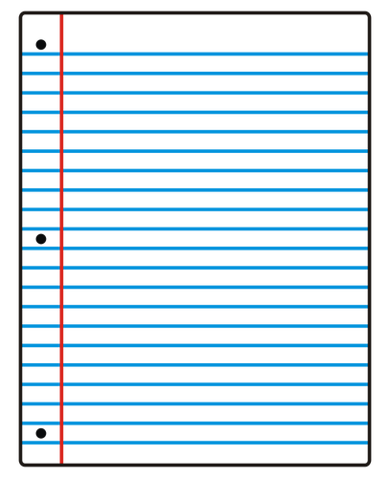
Self-Editing Worksheet: Encouraging Student Editing Accountability

Does your newspaper article have a heading that catches the reader’s attention?
Did you write your full name (first and last) underneath the heading?
Did you include at least 1 relevant picture in your article?
Did you write in 12pt Times New Roman font?
Did you separate your ideas into short paragraphs?
Are all the facts right? Double-check your statistics.

Are all names in the story spelled correctly?

Is the article free of spelling, punctuation, and grammar problems?

