Newspaper Basics
Content Checklist
Self-Editing Worksheet: Encouraging Student Editing Accountability

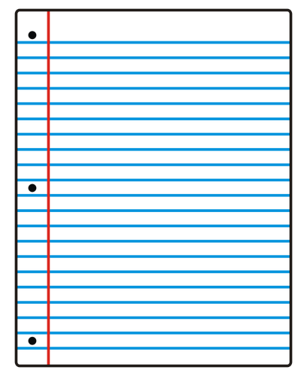
When writing or editing a news story, ask yourself these questions:

Does your newspaper article have a headline that catches the reader’s attention?

Does the lede capture the essence of the story? Is the main idea of the story explained clearly?

Is the lede 30 words or less? If not, can you tighten it?

Do the first few paragraphs of the article answer the who, what, where, when, why, and how questions?

Does the article have at least 1 lead quote? Is it properly attributed?

Did you save the background information/least important details for the end of the article?

Is the writing objective, free of editorializing?

Does the article follow the newspaper inverted pyramid structure, presenting information in descending order of importance?

