Article Ideas
Topic Checklist
Self-Editing Worksheet: Encouraging Student Editing Accountability

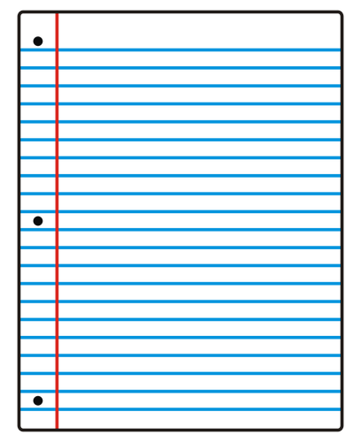
When trying to turn your topic into a newspaper article, ask yourself these questions:

What does this topic encompass? What are the issues within this topic?

What do I already know about this topic?

What do I want to learn about this topic?

How can I find more information on this topic? What websites, books, magazines, etc. can I read?

Who can I talk to about this topic? Who on the faculty, staff, administration, etc. knows something about this topic?
What is going on in the world that relates to this topic?

What has the newspaper already written about this topic? How can I build on what has already been written?

What are four story ideas I can write about on this issue in the next month or two?

