Day of Silence
Headline
Lead
Byline
By Chi Pham (Contributor)
Our Diversity Club organized the Day of Silence on Friday, April 12, 2019.
The Day of Silence is an annual event at CATS Academy Boston that gives participants (students, teachers, and staff members) an opportunity to understand the struggles of the LGBTQ+ community by taking a vow of silence for one day.
“There are so many people in the LGBTQ+ community that feel unsafe in public spaces like the cafeteria and cannot voice their identity because of the fear of judgment and bullying,” said Mrs. Carroll, head of the Diversity Club at CATS.
On the day of the event, the Club handed out wristbands and put up a poster for participants to sign and show support. All participants were then quiet from 8:00am to 3:35pm.
Details
“It was hard,” one participant said. “I wouldn’t say that I have truly felt the struggles of the LGBTQ+ people, but I imagine people must hide their true self for years. I was only quiet for a day, and it was almost impossible.”
After school at 3:45pm in Salon A, the Diversity club hosted a small event called “Break the Silence,” where participants gathered and shared their experiences of staying silent. It was interesting to hear stories from around the world and learn about how different cultures view gender and the LGBTQ+ community. Most impressive were the stories of students who have tried to bring conversations of openness and equality back to their country.
The Day of Silence may be over, but the struggles of the LGBTQ+ community continue. Join Diversity Club, and together we can use our voices to help promote equality and acceptance for everybody!
https://catsacademycourier.home.blog/2019/04/01/day-of-silence/

Extra Information

The Scholars Program Go to New York
Headline
Lead
Byline
By Mia Huynh (Lead Reporter)
On the chilly Saturday morning of January 12, fifteen students in the Scholars Program and three teachers headed towards New York City for a rejuvenating and enriching trip around the renowned New York University (NYU) campus, Washington Square, and the American Museum of Natural History.
Facts
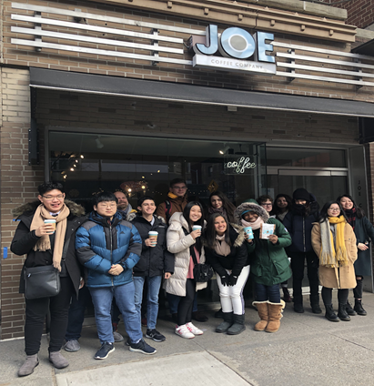
Feature Photo
Caption
CATS Scholars students at Joe Coffee near NYU

The coach bus departed CATS Academy early in the morning and arrived at Joe Coffee near NYU around 9 AM. When we walked inside the coffee shop, we were greeted by the rich smell of espresso and pastries. The more than three-and-a-half hour long drive was worth it. We enjoyed scrumptious snacks that the chaperones – Mr. O’Donnell, Ms. LaVallee, and Dr. Newman – brought and one another’s company. We then each grabbed something warm to drink and started making our way around the vast NYU campus, including its admissions center, schools, and libraries. Flocks of pigeons flying over our heads seemed to be guiding us toward the nearby Washington Square Park, where the grand, marble Washington Square Arch, built more than 100 years ago, stands. After marvelling at its beauty, we took a walk down Fifth Avenue to get lunch and hopped on the subway to go to the American Museum of Natural History (AMNH).
https://catsacademycourier.home.blog/2019/04/01/the-scholars-program-go-to-new-york/
Details
The AMNH, one of the largest museums in the world, was bustling with energy and activity. The museum includes 25 connected buildings, 46 exhibition halls, and more than 32 million specimens. We had the opportunity to see and read about dinosaur fossils, oceanic species, continental mammals, meteorites, human cultural artifacts and much more. As we studied the many artifacts of earth science, physical science, and life science, we learned a lot. Most importantly, the trip to the museum reignited our desire to continue learning about our enchanted world and its awe-inspiring history.
Looking back on the trip, Ms. LaVallee, the ESL Department Chair and ESL Teacher, said, “Going on a trip with the students is always an adventure, especially when the trip is to New York City…We were able to bring back many memorable moments to share. This is the true spirit of CATS!”
The trip was, in all aspects, an eye-opening mental health break for both the students and the chaperoning teachers. We hope this story of our trip inspires you to visit New York and explore NYU, the Metropolitan Museum of Art, and its other attractions!
Extra Information
https://catsacademycourier.home.blog/2019/04/01/the-scholars-program-go-to-new-york/

